CURRICULUM VITAE OF LETI NDUBANE
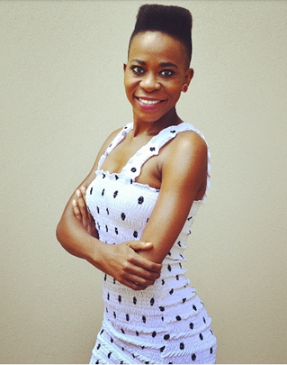 |  | gender: | Female
 |  | age: | 32
 |  | height: | 1,64
 |  | waist: | 30
 |  | hips: | 30
 |  | shoe: | 4
 |  | hair: | Brown
 |  | eyes: | Brown
 |  | languages: | Sotho, English, Conversational Afrikaans
 |  | accents:
SKILLS
TERTIARY EDUCATION
year | qualification |  |  | institution
2008 | Degree in Drama |  |  | University of Pretoria
THEATRE EXPERIENCE
year | production |  |  | role
2017 | Next of Next Week: Insurance educational theatre; Diprente Productions |  |  | Petunia
2017 | Caucasian Chalk Circle |  |  | Various Support
2015 / 2016 | One Woman Show |  |  | Lead
2013 / 2014 | Fanta Roadshow |  |  | Maude ( Lead )
 | Fanta Campaign
 | Enough is Genoeg |  |  | Matilda ( Lead )
 | Puppet Love Musical |  |  | Dancer
 | Office Space |  |  | Norma ( Lead )
 | Konfetti Children’s Theatre |  |  | Various
 | Ramalama Bang Bang |  |  | Pandora
 | Choreography Piece
 | Darlings You Were Wonderful |  |  | Vanessa ( Lead )
year | production |  |  | role
 | AIDS Awareness Production |  |  | Grethe ( Lead )
 | Car Trouble |  |  | Lettie ( Lead )
 | Curl Up and Dye |  |  | Mavis
FILM, TV & COMMERCIAL EXPERIENCE
year | production |  |  | role
2019 | Giyani (Tsonga Telenovela) |  |  | Featured
2017 | Capfin TVC |  |  | Featured
2016 | Ingozi |  |  | TK
2016 | Broken Vows |  |  | Support
2016 | Chicken Licken TVC |  |  | Newsreader
2015 | Dreamworld 2 |  |  | Rosie
2013 | End Games Firefox Media, SABC 1 |  |  | Constable Ndlovu
2013 | Class Divide Mzanzi Love Stories, Firefox Media, E-TV |  |  | Misty
2012 | Dreamworld Firefox Media, E-TV |  |  | Rosie
2012 | Polo Vivo TVC |  |  | Not Featured
2010 | Generations ( 1 year Arc ) SABC 1 |  |  | Keketso
2009 | Standard Bank Commercial |  |  | Pink Bunny
CORPORATE EXPERIENCE
year | production |  |  | role
OTHER EXPERIENCE
year | production |  |  | role/position

