CURRICULUM VITAE OF TSHIAMO MOBE
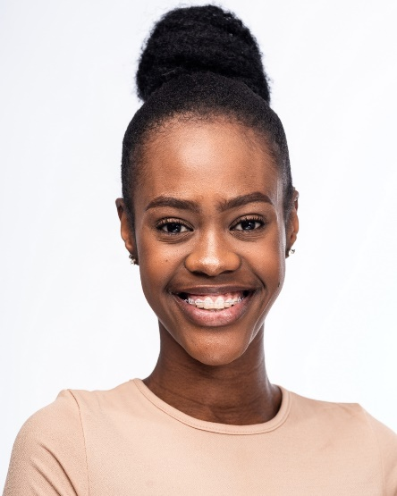 |  | gender: | Female
 |  | age: | 20
 |  | height: | 1.75
 |  | waist: | 28
 |  | hips: | 28
 |  | shoe:
 |  | hair: | black
 |  | eyes: | brown
 |  | languages: | English, Setswana, “Spitori”, Afrikaans
 |  | accents:
SKILLS
presenting, rapping, DJ’ing, poetry, singing and dance.
TERTIARY EDUCATION
year | qualification |  |  | institution
2019 | BA in Theatre and Performance (3rd year) |  |  | Wits University
THEATRE EXPERIENCE
year | production |  |  | role
2019 | Every Women’s Fear at Wits Nunnery |  |  | Nana
2019 | Native Psycopathology |  |  | Amina
FILM, TV & COMMERCIAL EXPERIENCE
year | production |  |  | role
2019 | Hyundai Grand i10 |  |  | Lead
2018 | Scandal (etv) |  |  | Twist Waitress (Featured extra)
2018 | PrintingSA |  |  | Customer (Supporting/Cameo)
2018 | Heineken Pan-African |  |  | Club members
CORPORATE EXPERIENCE
year | production |  |  | role
OTHER EXPERIENCE
year | production |  |  | role/position

