CURRICULUM VITAE OF SIMON MOSEHLA
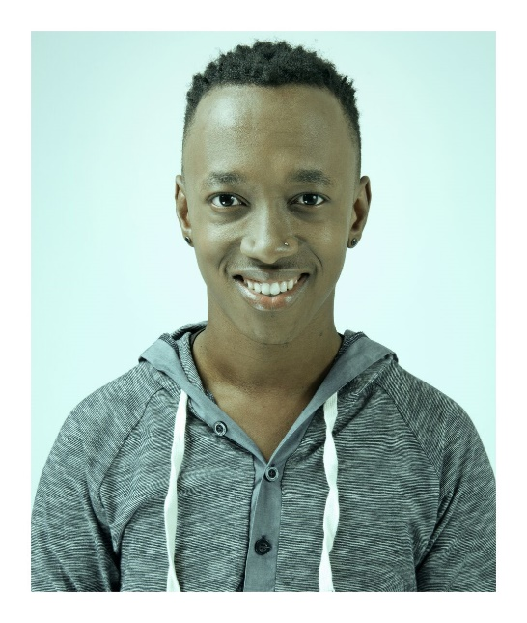 |  | Gender: | Male
 |  | Age: | 28
 |  | Height: | 1,56
 |  | Waist: | 28
 |  | Hips: | N / A
 |  | Shoe: | 6 / 7
 |  | Hair: | Black
 |  | Eyes: | Brown
 |  | Languages: | English, Sesotho, isiZulu
 |  | Accents:
SKILLS
TERTIARY EDUCATION
Year | Qualification |  |  | Institution
2013 | BA Drama |  |  | University of Pretoria
THEATRE EXPERIENCE
Year | Production |  |  | Role
2014 | Fanta Taste Like School Tour Offlimit Productions |  |  | Tristan
2014 | Fanta Turn Up Tour Offlimit Productions |  |  | Tistan
2013 | SANParks Community Project ( Puppet Show ) DIR: Myer Taub, Bailey Snyman |  |  | Various
2013 | Theatre for Development Project ( HIV / AIDS ) Centre for Sexualities, AIDS, and Gender |  |  | Facilitator
2012 | Theatre in Education ( Children’s Theatre ) SAPS |  |  | Various
2012 | Theatre for Development ( HIV / AIDS ) Centre for the Study of AIDS
2012 | Con(VERSE) DIR: Mona Monyane
2012 | Suikerbossie die Musical DIR: Jestre Marx and Chandre Botha
2012 | Gogola Anglo Gold Ashanti DIR: Lulama Masimini
CORPORATE EXPERIENCE
Year | Production |  |  | Role
2017 | Skills to Succeed promotional video (Accenture)  DIR: Dave Young |  |  | Sam
2016 | Skills to Succeed corporate film/application (Accenture)  DIR: Dave Young |  |  | Sam
OTHER EXPERIENCE
Year | Production/Company |  |  | Role/Position
2016 - 2017 | Buzz "Drama, Dance, Singing" |  |  | Primary Party and Workshop Leader

